**Broken Brakes Design Documents**

**Game Title:** Broken Brakes.

**Programmed and designed by**: Hussain Alnemer

**Story:** Your brakes are broken and you can’t stop your car. Try to avoid rocks and crazy drivers and rocks to survive for 30 seconds to win.

**Game play:** Move the red car with the mouse (or with finger if you are using a touch device) and try to avoid blue cars and rocks for 30 seconds to win.

**Game elements:**

**Red Car:** The player avatar. It can be moved across the screen with either mouse or fingers if touch screens are supported. It will stop at the edge of the scene.

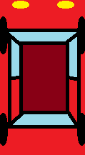

**Blue Car**: The main enemy. It moves in circular path with a variable (random) radius. The car will wrap when it reaches the end if the scene, create an unpredictable movement pattern. The “Crash” sound effect is played when the player crash into them. The player will lose the game if he/she collided with them.

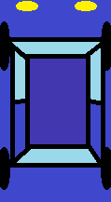

**Rocks:** Rocks are the secondary enemies of the game. They move slowly in straight lines across the scene. Once the reach the end of the scene, They response on the top of the scene again in a different x position. The “RockHit” sound effect is played when the player crash into them. The player will lose the game if he/she collided with them.



**Road**: It’s a sprite that moves vertically and wraps across the scene to give the illusion of movement.

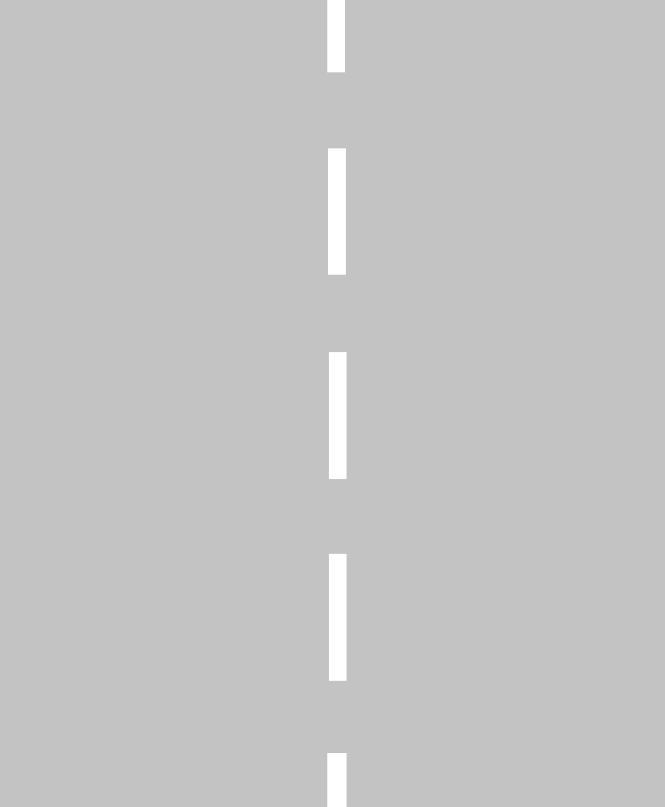

All Sound effects were generated with <http://www.bfxr.net/>